To setting up minikube on ubuntu 24.04 and exploring Kubernetes namespaces
Prerequisites:
Requirement | Notes
OS | Ubuntu 24.04 LTS
CPU | 2 vCPUs minimum
RAM | 4 GB minimum (8 GB recommended)
Disk | 20 GB free space
Container/VM runtime | Docker (recommended driver)
User privileges | sudo access

Step 01: Update the Ubuntu 24.04 LTS system after deploying a new VM and installing OS version.
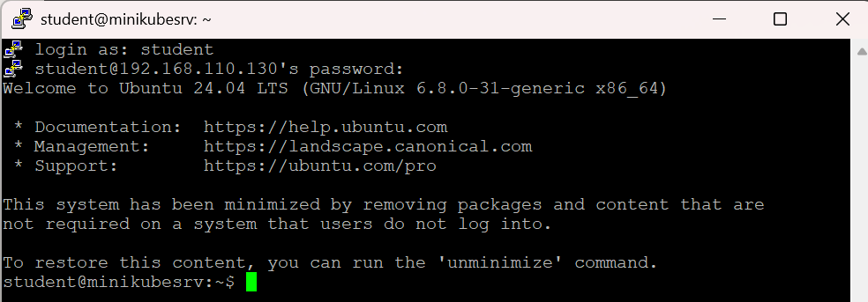

$ sudo apt update && sudo apt upgrade -y && sudo reboot
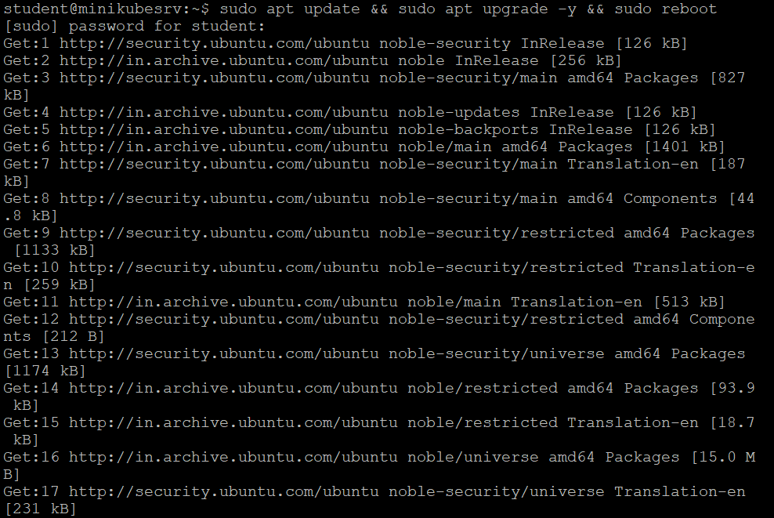
Step 02: Install Docker (container runtime / driver) after adding the docker repository and docker's official GPG key,
$ echo \
"deb [arch=$(dpkg --print-architecture) signed-by=/etc/apt/keyrings/docker.asc] https://download.docker.com/linux/ubuntu \
$(. /etc/os-release && echo "$VERSION_CODENAME") stable" | \
sudo tee /etc/apt/sources.list.d/docker.list > /dev/null
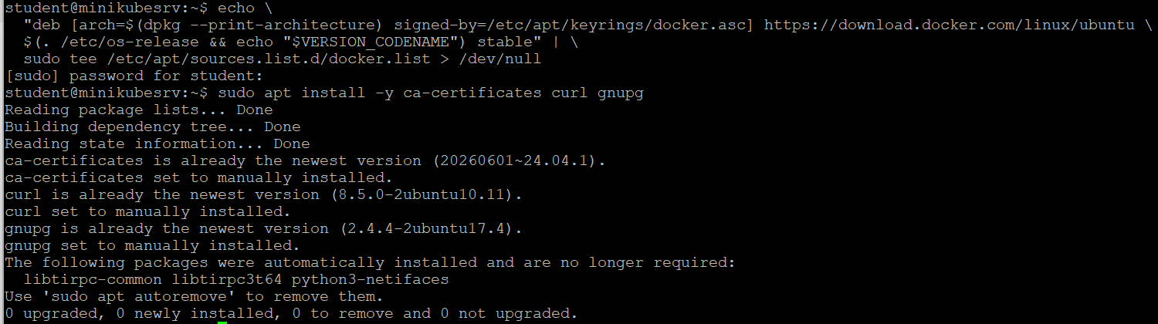

$ sudo apt install -y ca-certificates curl gnupg
$ sudo apt update; sudo apt install -y docker-ce docker-ce-cli containerd.io docker-buildx-plugin docker-compose-plugin
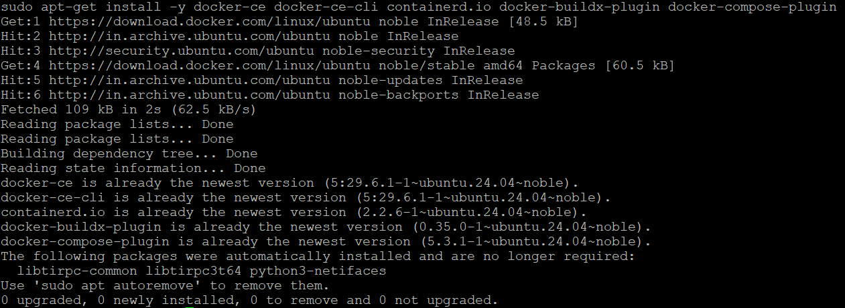

Step 03: Allow your user to run docker without sudo and verify:
$ sudo docker version
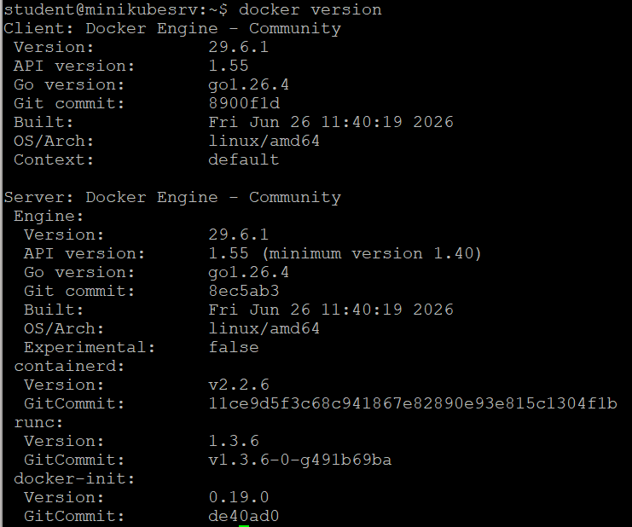
Step 04: Install minikube, start the cluster and verify the cluster
$ curl -LO https://github.com/kubernetes/minikube/releases/latest/download/minikube-linux-amd64
$ sudo install minikube-linux-amd64 /usr/local/bin/minikube
$ rm minikube-linux-amd64
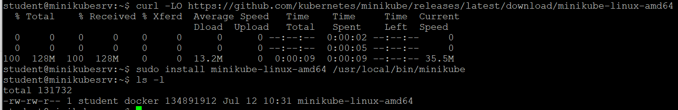

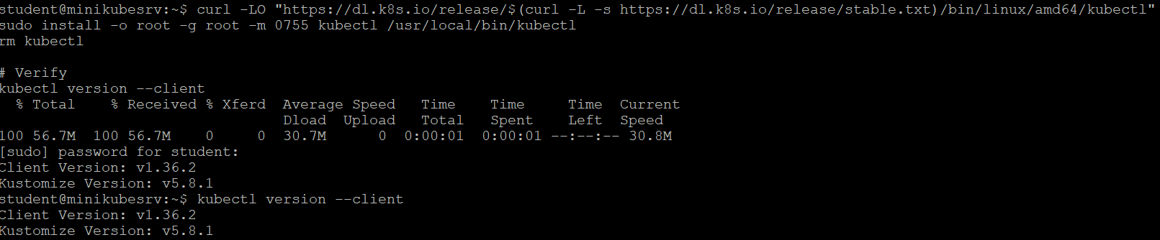

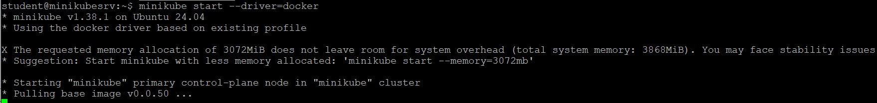

$ minikube start; kubectl get nodes
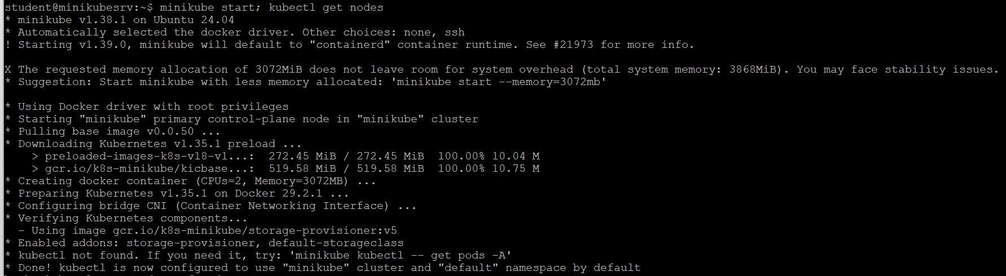

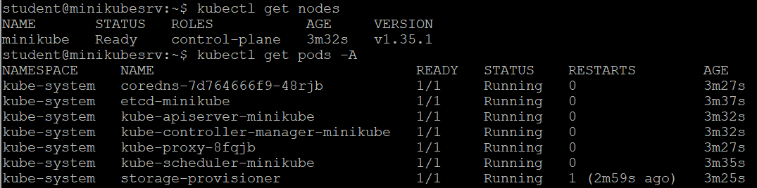

Step 05: Access the minikube dashboard:
$ minikube dashboard
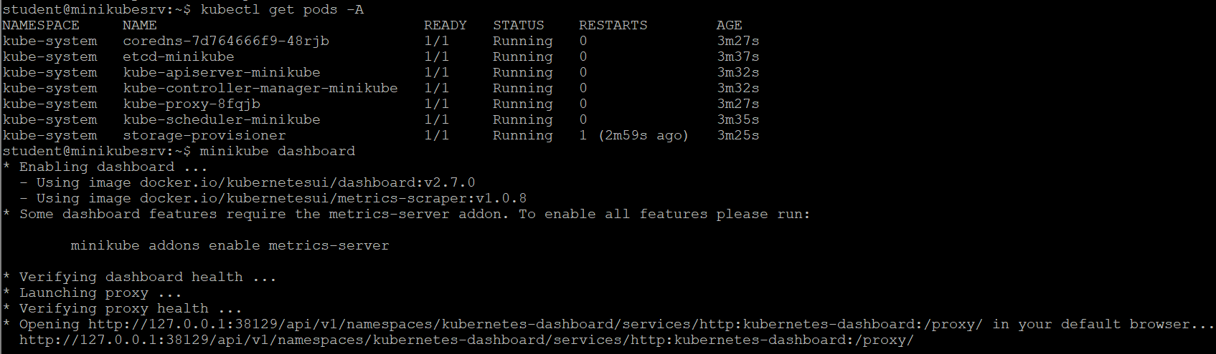

Step 06: Work with Namespaces (list namespaces, create a namespace and use namespace in deployments):
$ kubectl get namespaces
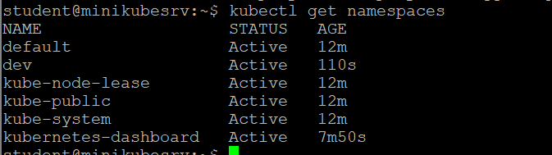
$ kubectl create namespace dev
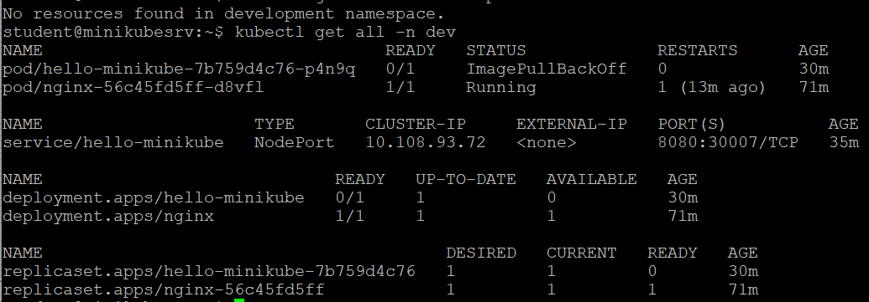

$ kubectl get svc -n dev
$ kubectl create deployment nginx --image=nginx -n dev
$ minikube service hello-minikube -n dev
